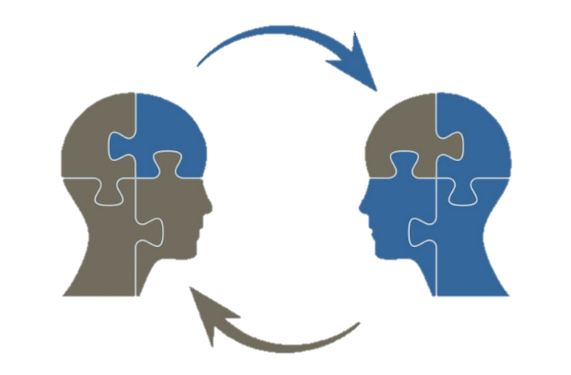
TRIP (Turning Research into Practice) Briefs
WHY commit time to learning about Evidence-Based Practices?
Excerpts from Cook, BG & Odom. SL. (2013). Evidence-based practices and Implementation science in Special Education. Exceptional Children, 79 (2), pp. 135-144, and Cook, BG & Cook, SC. (2011) Unraveling evidence-based practices in Special Education. The Journal of Special Education, 47(2), pp. 71– 82.

What exactly do we mean by “EBPs”?
EBPs are unique among efforts to determine effective practices in that, as detailed below, a trustworthy body of research that meets specific standards of rigor must support these practices. Originating in medicine in the 1990s (e.g., Sackett, Rosenberg, Gray, Haynes, & Richardson, 1996), the identification of EBPs soon spread to fields such as agriculture, nursing, psychology, and education (Slavin, 2002). As EBPs represent practices found to be effective by the most reliable research, they have significant potential to affect meaningful, positive change in education (Slavin, 2002)—especially for students who are at risk for school failure (e.g., students with disabilities) and require the most effective instruction to reach their potentials (Dammann & Vaughn, 2001).

EBPs are:

- practices that are supported by multiple, high-quality studies
- that utilize research designs from which causality can be inferred (group experimental, group quasi-experimental, and single subject)
- that demonstrate meaningful effects on student outcomes

Say Something…….

Why are we talking about EBPs?

The gap—described by some as a chasm (e.g., Donovan &C Cross, 2002)—between research and practice is a recurring theme in special education. Indeed, we suspect that the gap has been present in special education as long as research and practice have co-existed. Attempts to bridge the research-to-practice gap by identifying and implementing effective practices are a rich part of special education's history (Mostert & Crockett, 1999-2000). Despite considerable focus on the research-to-practice gap (e.g., Carnine, 1997; Greenwood & Abbott, 2001) and on identifying EBPs as means to bridge it (e.g.. Cook et al., 2009b; Odom et al., 2005), there is little evidence suggesting that the gap has been meaningfully reduced. For example, a U.S. Department of Education report (Crosse et al., 2011) noted that only 7.8% of prevention programs related to substance abuse and school crime used in over 5,300 schools met their standards for an EBP. And, in special education, practitioners have reported using instructional practices shown by research to be ineffective (e.g., learning styles) with similar or greater frequency than some research-based practices (e.g., mnemonics; Burns &C Ysseldyke, 2009).

Say Something…….

Incomplete and Variable Identification of EBPs. Although more and more EBPs are being identified in both general and special education, because of the considerable time and expertise it takes to complete an evidence-based review (i.e., apply standards for EBPs to the body of research literature examining the effectiveness of a practice) many practices have not yet been reviewed. And because of the relative scarcity of high quality, experimental research in the educational literature (Berliner, 2002; Seethaler & Euchs, 2005), many evidence-based reviews result in the conclusion that there is simply not enough high quality research utilizing appropriate designs to meaningfully determine whether a practice is evidence-based. In other words, just because a practice is not considered an EBP does not necessarily mean that it is ineffective. It is then important to distinguish between practices that are not considered evidence-based because (a) they have been shown by multiple, high-quality research studies from which causality can be inferred to be ineffective and (b) an evidence-based review has not been conducted or there is insufficient research to conclusively determine whether the practice is effective [Comment: in the Network, we will consider this a promising practice.] (Cook & Smith, 2012). The former practices should rarely if ever be used, whereas the latter might be implemented when relevant EBPs have not been identified or a student has been shown to be a nonresponder to identified EBPs.

Say Something……

… it may seem that special educators would be better served by pursuing practices that appeal to teachers and are easily implemented, but which are less effective (i.e., typical practice), than by chasing the large effects of EBPs that may be difficult to realize. However, special educators sell themselves short—and, more important, do a disservice to the students they serve—by settling for practices with limited effects.

What are your matchbox answers to:

- What are evidence-based practices?

- What is a promising practice?

- What is an ineffective practice?

